# CS 255 System Design Document Template

This template lays out all the different sections that you need to complete for Project Two. Each section has guidance to prompt your thinking. You will need to continually reference the interview transcript as you work to make sure that you are addressing your client’s needs. There is no required length for the final document. Instead the goal is to complete each section based on what your client’s needs are. Remove this note when you are finished, and replace all bracketed text with the relevant information.

## UML Diagrams

### UML Use Case Diagram

### UML Activity Diagrams

I chose the activities for logging into the system and the driver reservation system.

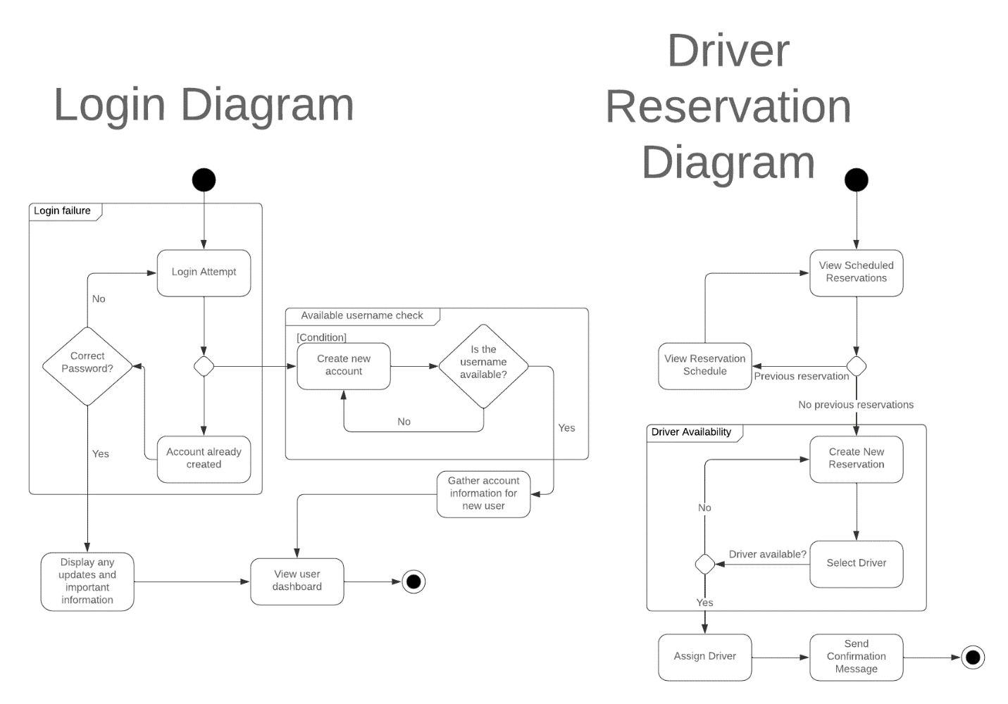

### UML Sequence Diagram

This sequence diagram depicts someone logging into the system.

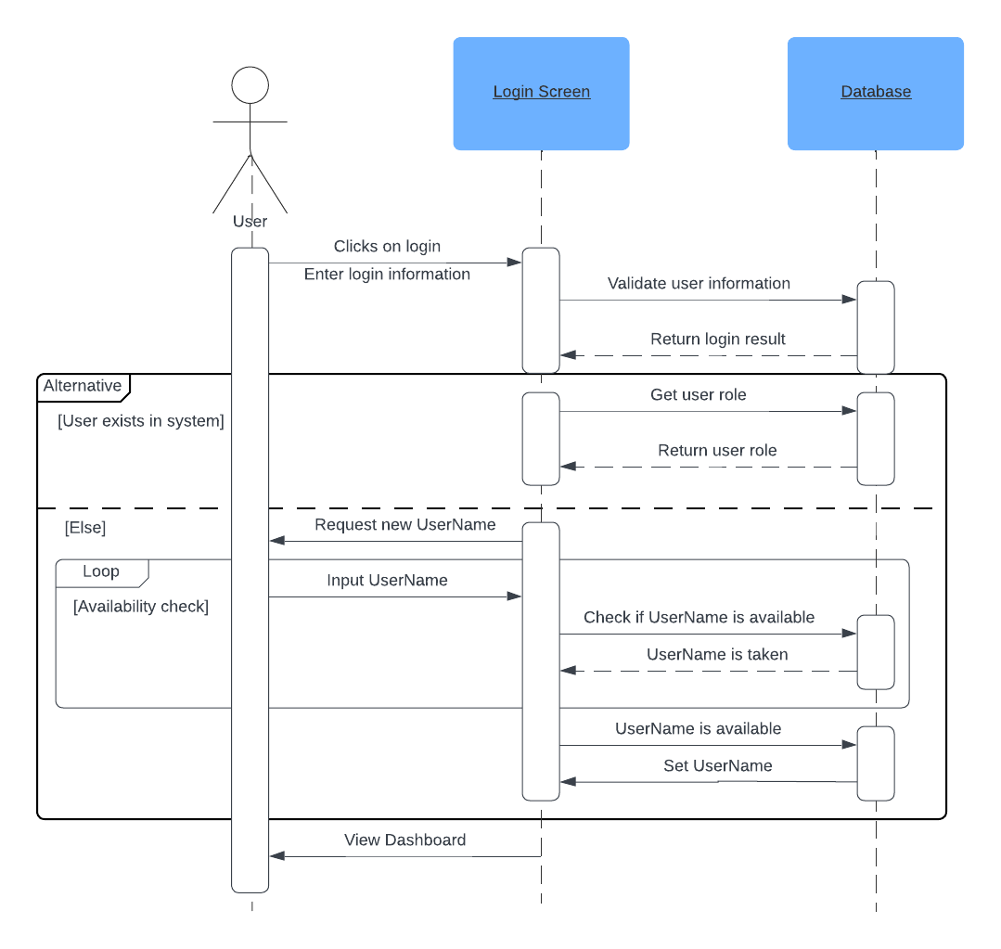

### UML Class Diagram

## Technical Requirements

*[Based on the diagrams you have created, describe the technical requirements of your system. These requirements should address the required hardware, software, tools, and infrastructure necessary for your system design.]*

Technical requirements include:  
Access to a web browser.

Scalable architecture.

Report export type of CSV.

Hardware that connects to the internet.

A cloud server to store the system and hold the database.

RESTful API techniques.

Webpages tested on iOS, Android, and Chromium systems.

Testing to ensure system has at least a 99% uptime.